# //EXPERIMENT-07 //BRAUN ARRAY MULTIPLIER //RA2111004010177

**//Post lab //wallace Tree** module wtm_177(p, a,b);

output [7:0] p; input [3:0] a,b; wire s11,s12,s13,s14,s15,s22,s23,s24,s25,s26,s32,s33,s34,s35,s36,s37; wire c11,c12,c13,c14,c15,c22,c23,c24,c25,c26,c32,c33,c34,c35,c36,c37; wire [6:0] p0,p1,p2,p3; assign p0 = a & {4{b[0]}}; assign p1 = a & {4{b[1]}}; assign p2 = a & {4{b[2]}}; assign p3 = a & {4{b[3]}}; assign p[0] = p0[0]; assign p[1] = s11; assign p[2] = s22; assign p[3] = s32; assign p[4] = s34; assign p[5] = s35; assign p[6] = s36; assign p[7] = s37; //1st stage ha ha11(s11,c11,p0[1],p1[0]);

fa fa12(s12,c12,p0[2],p1[1],p2[0]); fa fa13(s13,c13,p0[3],p1[2],p2[1]); fa fa14(s14,c14,p1[3],p2[2],p3[1]); ha ha15(s15,c15,p2[3],p3[2]); //2nd stage ha ha22(s22,c22,c11,s12); fa fa23(s23,c23,p3[0],c12,s13); fa fa24(s24,c24,c13,c32,s14); fa fa25(s25,c25,c14,c24,s15); fa fa26(s26,c26,c15,c25,p3[3]); //3rd stage ha ha32(s32,c32,c22,s23); ha ha34(s34,c34,c23,s24); ha ha35(s35,c35,c34,s25); ha ha36(s36,c36,c35,s26); ha ha37(s37,c37,c36,c26);

endmodule **//Test bench** module wtm_177_tb_v;

// Inputs reg [3:0] a; reg [3:0] b; // Outputs wire [7:0] p;

// Instantiate the Unit Under Test (UUT) wtm_177 uut (

.p(p),

.a(a),

.b(b)

);

initial begin // Initialize Inputs a = 0; b = 0;

// Wait 100 ns for global reset to finish

#100;a=4'b1100;b=4'b0110;

#100;a=4'b1110;b=4'b0101;

#100;a=4'b1000;b=4'b0111; // Add stimulus here end endmodule

# //Half Adder

module ha(sum, carry, a, b); output sum; output carry; input a; input b; xor g1(sum,a,b); and g2(carry,a,b);

endmodule **//output**

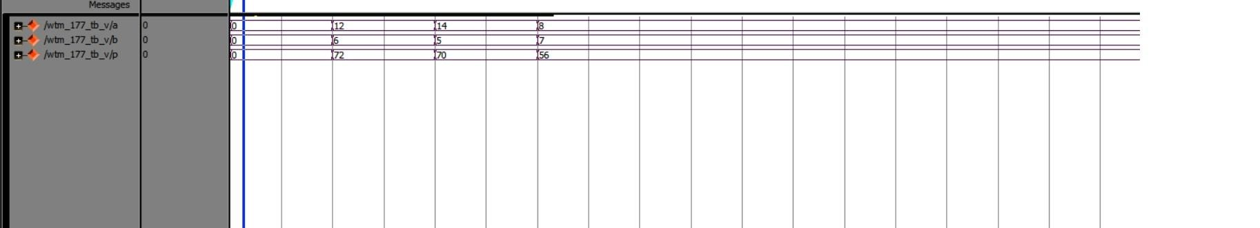

**//RTL schematic:**

